[ Insert official UPAEP logo ]
UPAEP · Decanato de Ingenierías
EVIDENCE — US14-T3
Build the actuator status panel
SmartGreenAI: Cilantro Crop

1. Task information
Task ID | US14-T3
User Story | US-14 — View actuator status
Sprint | Sprint 2 (2026-09-21 – 2026-10-09)
Week | Week 2
Responsible | Oscar Abraham Talavera Nava
Peer reviewer | Vicente Rocha Alfaro
Planned / actual hours | 2 h / 2 h
Completed on | October 2, 2026
Status | Done

2. Task description
Add a panel to the dashboard with one card per actuator showing name, type, state (with color and text, not only color) and last update. The panel refreshes automatically (e.g., every 30 s).

3. Completion conditions
✓ Condition 1: Dashboard shows one card per actuator with name, type, state and last update.
How it was verified: The dashboard shows one card/row per actuator with name, type (ID), state and last update.
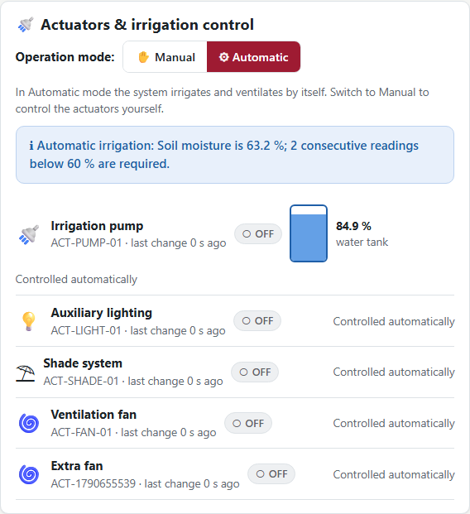
Figure US14-T3-1. Actuator panel at 04:19:20 UTC: one row per actuator with icon, name, type/ID, state badge and last change; the fan is OFF. (US14-T3_Build_Actuator_Status_Panel_1.png)
✓ Condition 2: State is shown with color and text.
How it was verified: The state is shown with colour and text (and an icon), never with colour only.
Badges rendered in the panel (text → colours)
○OFF → rgb(95, 99, 104) on rgb(238, 240, 242)
○OFF → rgb(95, 99, 104) on rgb(238, 240, 242)
○OFF → rgb(95, 99, 104) on rgb(238, 240, 242)
⏻ON → rgb(46, 125, 50) on rgb(231, 244, 232)
○OFF → rgb(95, 99, 104) on rgb(238, 240, 242)

public/js/ui.js — lines 88–93
export function stateBadge(state) {
if (state === 'ON') return badge('ok', 'ON', '⏻');
if (state === 'OFF') return badge('neutral', 'OFF', '○');
return badge('danger', 'OFFLINE', '⚡');
}
export function activeBadge(active) { return active ? badge('ok', 'Active') : badge('neutral', 'Inactive', '○'); }

✓ Condition 3: Panel refreshes automatically at the defined interval.
How it was verified: The panel refreshes automatically every 30 seconds: the fan state changed at 04:19:20 UTC and the open page showed it at 04:19:49 UTC without a reload.
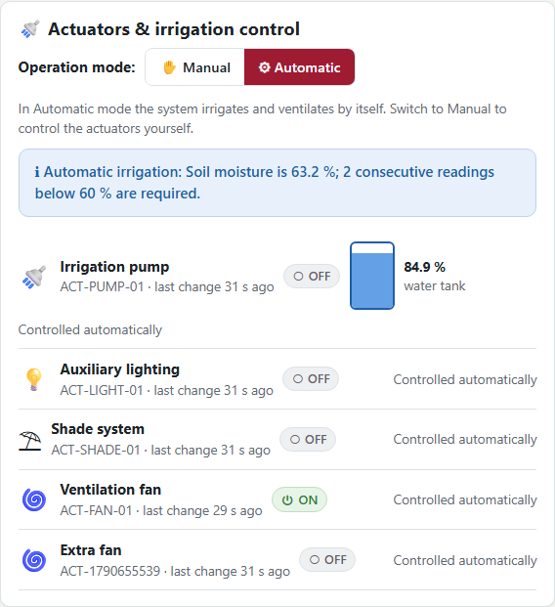
Figure US14-T3-2. Without reloading the page, 29 s after the fan reported ON, the panel refreshed and shows "ON" (auto-refresh every 30 s). (US14-T3_Build_Actuator_Status_Panel_2.png)
public/js/pages/producer-dashboard.js — lines 397–397
every(30000, refresh);

✓ Condition 4: Evidence: Panel visible in the dashboard with real or simulated data.
How it was verified: Panel visible in the dashboard with data reported by the (emulated) device.

4. Attached files
- US14-T3_Build_Actuator_Status_Panel_1.png
- US14-T3_Build_Actuator_Status_Panel_2.png

5. Traceability
Related requirements | FR-16, NFR-06
Implementation | See docs/TRACEABILITY.md
Verification | See docs/TRACEABILITY.md

6. Sign-off
Role | Name | Date | Signature
Responsible | Oscar Abraham Talavera Nava | October 2, 2026
Peer reviewer | Vicente Rocha Alfaro | October 2, 2026
Product Owner acceptance | Alexis Enrique Valle Parra | October 2, 2026
Approval record: Daily Meeting 3 of Sprint 2 (Monday, October 5, 2026), team update: Oscar Abraham Talavera Nava — "US07-T3, US07-T4, US14-T2 and US14-T3 finished; panel refreshes every 30 s."

